Problem 1: Projectile Motion with Drag and Wind

Problem: Solve the projectile motion with both drag and wind included.



Figure 1: Projectile with Drag and Tail Wind

Distance of the matlab solution is 480. Slight shorter due the variation in the slider values from the exact values in matlab.

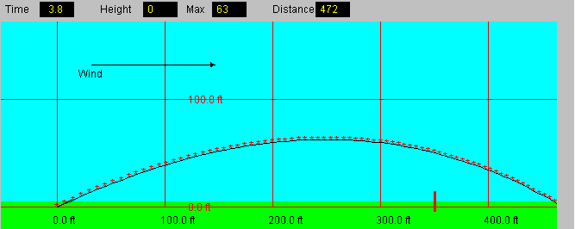

Figure 2: Projectile with Drag and Tail Wind



Figure 3: Projectile with Drag and Head Wind

Distance of the matlab solution is 246 ft. Slight shorter due the variation in the slider values from the exact values in matlab.

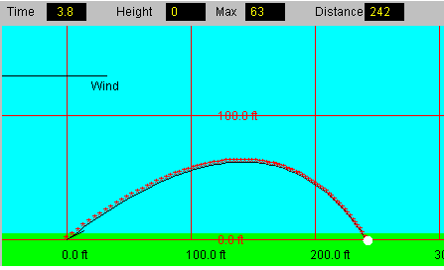

Figure 4: Projectile with Drag and Head Wind

Problem 2: Mechanical System with Applied Force

**Problem:** Find a Force where x(t) is never negative given that when v>0 F = 0 and when v<0 F=A



Solution: Using matlab minimum force needed for positive x displacement is 1.07.

while tcount<=tmax

if v(i)>=0 %checks for negative velocity and how to set the force

Fapplied = 0;

else

Fapplied = Fx;

end

vgrad(i) = (-(K1+K2)*x(i)+K1*y(i)-B1*v(i))/M;

ygrad(i) = (4/B2)*(K1*x(i)-K1*y(i)+Fapplied);

v(i+1) = v(i) + vgrad(i)*dt;

x(i+1) = x(i) + v(i)*dt;

y(i+1) = y(i) + ygrad(i)*dt;

i = i + 1; %while loop counter

tcount = tcount + 0.1; %time step = 0.1;

if x(i)<0 %Reset Process and Increase Applied Constant Force

farray(n) = Fx; %stores change in force in an array

Fx = Fx+0.01;

i = 1;

tcount = 0;

n = n+1; %for loop counter

end

end